Organizational behavior review
Topic
- Well being
- Motivation model, process model

Well being
- Study questions
- What is wellbeing, stress and others
- Stress and different between challenges and hindrance stressor
- Demand – resource model
- Source of stress: environmental factor, organizational factors, personal factors
- Moderator of the relationships between potential stressor and experienced stress
- Consequence of stress
- Managing stress: individual approach and organizational approach
- Different types of wellbeing and different between them

- What is wellbeing
- Definition of wellbeing
= The definition of well-being has been argued for many years
= In the past studies said people who has high in psychological wellbeing should has an excess of positive affects over negative affects
= Or life satisfaction (related to sense of satisfaction of life ), pleasant affect and unpleasant affect (related to mood and emotion )
= The new definition define it as a equilibrium between resource and challenges of psychological, social and physical

- What is stress
- Definition
= stress is a dynamic condition in which a individual is confronted with an opportunity, demand, or resource related to what the individual desires and for the which outcome is perceived to be both uncertain and important
= stress appear when demand is much more than the resource

- Challenges and hindrance stressors
- Challenge stressor- associated with workload, pressure to complete task and time urgency
-people view it as challenges of their opportunities for personal development and achievement
- Hindrance stressor- associated with keeping you from reach your goal (red tape, office politics, confusion over job responsibility)
-people view it as obstacle of their personal gain and success
research suggested the challenges produce less strain than hindrance stressor
work is the most importance resource of stress in life (26% of people respond)
work stressor are the stimuli’s that induce the stress process and form of strain (anxiety, tension and exhaustion) are the outcome of the process
- Hindrance have more effect on negative outcome of the strain process than challenges stressor
challenges increase motivation because it likely to gain resource than hindrance
Relation of two factor stressor to work related variables
 | Job satisfaction | Job search behavior | Turnover | Performance | Propensity to leave | Job attitude | Organizational commitment
Challenges | + | - | - | + | + | - | -
Hindrance | - | + | + | x | + | - | -

- Demand - resource model
基本原理
- This model was introducing to as an alternative to the demand control model and the effort-reward imbalance model
- Every occupation might have its own risk factor associated with job stress, they can be classified as job demand and job resource
- Stress is associated with demand and resource

demand:
responsibility
pressures
obligation
uncertainty individual face in work
resource:
things within people’s control
can use to solve demand
inside or outside resource that you could use

- Adequate resource help reduce the stressful nature of demand when demand and resource are matched
- The negative effect of that type of job demand will be mitigate by that types of resource (or job resource will buffer job demand influence on job strain)
Example
- For example, if experience emotional demand, emotional resource like social support will reduce the strain cause by demand
- If cognitive demand like brain information overload, resource like help from computer on processing information will help to reduce strain

早期的模型
job demand is job that required physical and mental effort that will led to certain physiology and psychological cost
When job demand is high, extra effort will be needed to put in to maintain the work quality
job resource those physical, social or organizational aspect of the job that may
- Functional in achieve work goal
- Reduce job demand and associated cost
- Stimulate personal growth and development

新的模型
增加了正面的部分，work engagement

Health implication process
work engagement as a mediator between job demand and health problem and
Job resource and turnover demand
new theory suggest that burnout will led to health problem like depression, cardiovascular disease or psychological complain， 崩溃可能会导致抑郁，心脏类疾病以及精神疲劳

Motivational process
Work environment that offer many resources will foster works willingness to put their effort and ability into work task, low cynicism and excellence performance
extrinsic motivational role willing to spend more effort and foster goal achievement
intrinsic motivational role, satisfying human needs of autonomy, relatedness and competence, foster employees’ growth and development

- Experiment suggest that high job resource and low job demand led to low job strain and high motivation
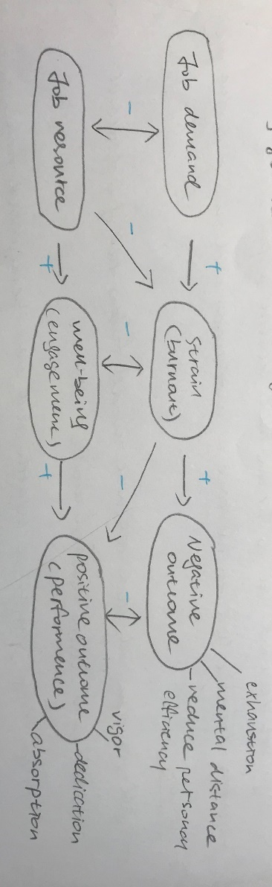Criticism and advantage
好处
any demand and any resource principle of this model allow this model to be
Tailored in to specific needs of all organization and situations
consider both the negative, positive, cause and outcome
able to implement on bridge between occupational health management and human resource management
不足
it has been criticized of been to board in context, it satisfy the relationship between group of variables without provide any particular explanation of psychological reasons. The utilization of this model always have to explain why a specific demand are correspond to a resource
the concept of JD and JR haven’t been defined clearly, lack of resource = resource demand ？
the model suggest a linear relationships, but actually these variable can be mutually influenced and there are exist of gain cycle
- Source of stress
- There are three source of stress, environmental, organizational and personal

- Environmental factors
Is the environmental uncertainty that influence organizational structure and level f stress, which is the biggest reason why people have difficulties dealing with organizational change
- Economic uncertainty
When economy is contracting, like the increase uncertainty increase anxiety about job security, or recession
- Political uncertainty
The stability of the political system tended to affect some country more than others, terrorism, Brexit, corruption, and election that threat the development of the nation, the development of a country and influence the skill and ability of an employee in the future or the personal safety of citizens
- Technological uncertainty
For example, the appeal of AI will affect the job security and the potential of changing organizational structure, job role and others. The insecurity of been fire or replaced by AI might led to stress

- Organizational factor
- Task demand
Related to person’s job, include design of the job ( degree of autonomy, task variety, degree of automation) , working conditions, and physical workplace layout
Eg: assembly line, overcrowded room, visible location where noise and interruption can be visited, boss office can monitoring all the desk, block working place, military style …
a research had found that Lean production can be a better implication in manufactory in related to workers wellbeing, more control over each process, the material right in time until employees finished the last step, personal workspace
- Role demand
Related to pressure that place on a person as a function of particular role they play in the organization
Role conflict, role overload means expected to do more in time pressure, role ambiguity means employees role are not clear or not sure what to do
people who face high situational constrain might have less ability to proactively coping with reducing stress level 工作情况受限制的人更不容易去主动解决压力问题
- Interpersonal demand
is the demand crested by other people in the office, lack of social support, poor interpersonal relationships, especially for people with high social need.
a research has shown relationship between negative co-worker and supervisor behaviour (fight, bullying incivility, racial harassment, and sextual harassment) and stress at work
- Personal factors
People only work for 40-50 hours a week, experience and problem in the rest of the 100s hours can largely influence employees work behaviour a lot
- Family problem and personal relationships
Marriage problem, breaking of relationship, family member accident, children
- Economic problem
Feel difficult to do financial on their income, money management and save money \
- Personality
Studies have shown some people might have higher tendency to accentuate negative aspect of the world
A person’s personality can highly influence how they react, perceived and cope with stress

- Moderator of stress effect
However, there are some character of individual that can moderate the effect of stress on their well being

- Consequence of stress
- Physiological symptoms
change in metabolism, increase heart and breath rate, blood pressure, headache, heart attack, musculoskeletal disorder in the upper part of body, neck, shoulder, back, poor immune system functioning
UK study have found stress associated with high level of coronary heart disease
Danish research have found psychological burnout related to sickness absence

- Psychological symptoms
job dissatisfaction is the simplest and obvious effect
tension, anxiety, irritability, boredom, procrastination
research have found stress related to lower emotional well-being
job with less control, employees will have more stress tendency and low in satisfaction

- Behaviour symptoms
will reduce in performance, productivity, absence, and turnover
change in eating habit, increase smoking, drinking alcohol, rapid speech, and sleep disorder
stress performance relation
Research have found low to moderate stress will led to perform better, intensive working and speed up
Too much stress led to low performance
Also challenges stressor led to higher performance compare to hindrance stressor that led to decrease of performance
two process of burnout 两个崩溃的步骤
- Long-term excess of job demand, fail to adequality recover from excess use of ability, led to sustain activation and overuse burnout 长期的对工作的期望，没有休息导致了能力的过度使用,
- Lack of resource to preclude the job demand are met or the goal been reach withdraw behaviour 没有能显示工作期望或者目标被达到的标准导致了放弃的举动
- Long term exposure to stressor will led to emotional exhaustion, dehumanization (develop a negative, callous and cynical attitude toward work, colleagues and customers.

- Manage stress (individual and organizational approach)

- Different well beings

Motivation at work
- Study question
- What is motivation at work
- That basic principle of the specific motivation theory
- Process theory :
- Reinforcement theory
- Goal setting theory
- equity theory
- vroom’s expectation theory
- The shortcoming of this specific theory
- Outline some of the other theory of motivation and differentiate between each theory

